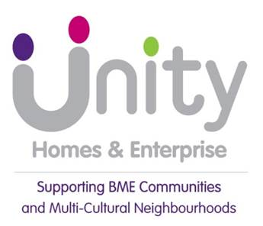
UHA BOARD MEETING 24 JUNE 2026
ANNUAL COMPLAINTS REPORT 25-26
- RECOMMENDATION

  - It is recommended that Board note and comment on:
- Performance on complaints in 2025/26

- the key facts and figures for the year on complaints in 2025/26 (appendix 1)

- the amendment to the complaints policy at stage 2 in Unity’s process which introduces the option of the complaint being reviewed by a panel

and approve
- the annual self-assessment against the Complaints Handling Code (appendix 2)

- CONFIDENTIAL – NO
- IMPACT ASSESSMENT ON CROSS CUTTING THEMES

THEME | IMPACT – Positive and / or Negative | Relevant  to report?
Risk (strategic risks,  risk appetite etc.) | If complaints are not dealt with in line with the complaint handling code guidance and timescales, and all factors of the complaint are not answered, this could result in financial and reputational damage to the association. | Y
Health and  Safety | No specific considerations
Governance | Failure to comply with the Complaint Handling Code can lead to a Complaint Handling Failure Order (CHFO) by the Housing Ombudsman and a referral to the Regulator. | Y
RSH economic  regulatory standards | No specific considerations
RSH consumer  regulatory standards | The effective management of complaints is a component of the consumer standard and has been brought back into the fold for a regulatory inspection. | Y
Other statutory/ regulatory compliance, legal etc. | No specific considerations | N
Financial | Complaint affects our finances in 3 ways.  The redoing of what should have been done right in the first place.  Compensation payments  Admin costs of dealing with complaints | Y
Value for money | Upheld complaints are a failure to do things right first time,  and is poor value for money. | Y
Equality, diversity &  Inclusion | We monitor take up of the service and satisfaction of complaint.  handling to ensure the service meets the needs of everyone. | Y
Human resources | No specific considerations | N
Customer  voice/impact | Complaints form a valuable part of our customer feedback process. | Y
Social Purpose | To achieve Unity’s social purpose, resources need to be adequately managed. This report refers to a number of areas related to the delivery of the organisation’s social purpose | Y

- Background and purpose
4.1 This is the annual report on complaints for the period April 2025 to March 2026. A shorter overview report on complaints performance for the year was presented to Operations Committee in May 2026.

4.2 The report provides a summary of performance on complaints during the year (Appendix 1) with an analysis on themes coming out from the complaints and the lessons learnt.

4.3 The report also brings to the Board’s attention a change in Unity’s Complaints policy at stage2 which now gives the resident the option of having the complaint reviewed by a panel made up of a Director, and either one or both from a Board member and a member of the Tenant Scrutiny Group. This change was requested by the Tenant Scrutiny Group in 2023 and promised by the Operations Committee but not enacted for various reasons. The first stage 2 complaints have been being heard recently by a panel which included our Board Lead Member for Complaints, the chair of TSG and the CEO in one panel and our Complaints Lead Officer in the other panel.

4.4 Also included is the annual self-assessment against the Housing Ombudsman’s Complaint Handling Code (Appendix 2). The Code took effect from April 2024 and so this is the second assessment of the Code and it is a Regulatory requirement that Board approve an annual self-assessment against the Code. We received confirmation of being compliant with the Code from the Ombudsman last year and there has not been a need to change anything in the self-assessment this year.

5. Review of Complaints performance 2025/26 (Appendix 1)

5.1 A total of 94 complaints were received during the year of which 24 (26%) escalated to stage 2. This is a significant increase in number compared to the previous year when we received 40 complaints.
5.2 Stage 1 complaints had a 76% response rate on time compared to 94% in 2024/25 and stage 2 complaints had a 96% response rate on time compared to 82% in 2024/25. In terms of numbers this translates to 23 stage 1 complaints and 2 stage 2 complaints not responded to on time. One of the stage 2 complaint was under the new process with a panel review hearing and was delayed due to the unavailability of the tenant.
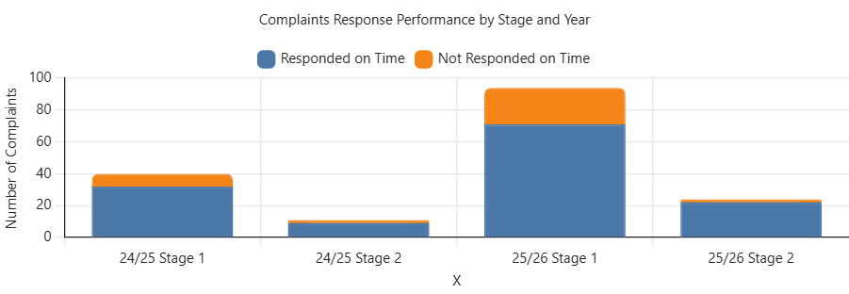
5.3 The drop in performance on response times are reflective of the failure earlier in the year in responding to complaints on time from the previous Property Services Manager and the lack of oversight on complaints due to not having a Complaints Lead Officer.
5.4 Changes were made in September with the introduction of a new policy, new complaints tracker and a new Complaints Lead Officer who also delivered refresher training to all service managers.
5.5 This had a positive impact on performance and response rates for stage 1 improved to 91% in Q4 and overall, since September to 89%. This was despite increasing case volumes.
5.6 Response rates by quarter periods over the year are shown below:
- Left graph: Cases received by quarter
- Right graph: Response rate by quarter

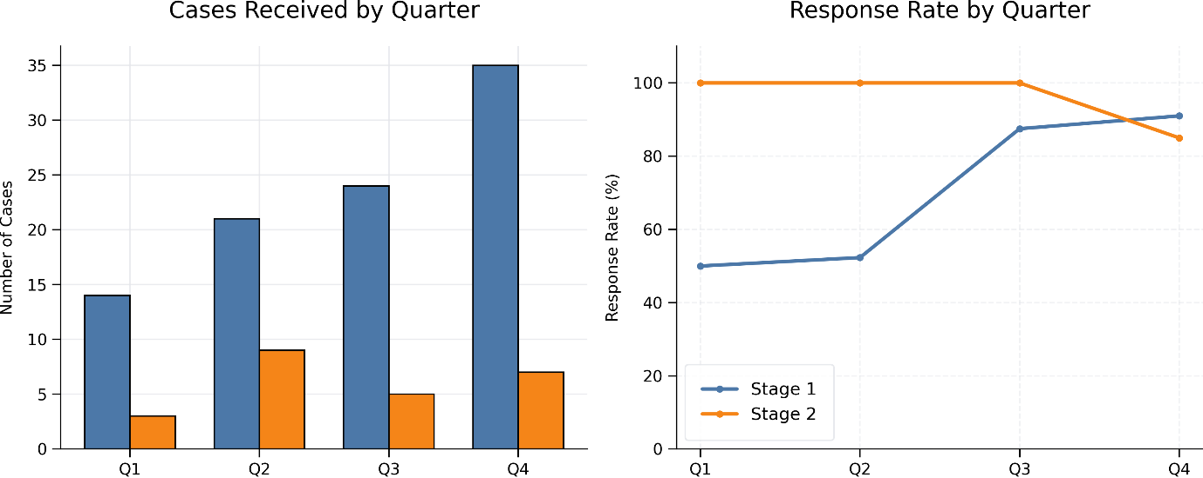
5.7 The significant increase in complaints both at stage 1 and stage 2 compared to the previous year is down to a number of potential factors:
- an increase in contractor failures due to unsatisfactory performance and communication
- poor customer service and communication from Unity staff due to the turnover in the customer service team during the year
- continued work done by Unity to publicise and promote the complaints processes and performance information through it’s communication channels (Scrutiny Committee, newsletters and the website)
- rising expectations of tenants.
5.8 Of the 94 stage 1 complaints Unity upheld 47 and partially upheld 17 so 68% of complaints were upheld or partially upheld. At stage 2, of the 24 complaints 14 were upheld and 2 were partially upheld (67% in total upheld or partially upheld).
5.9 Two complaints were raised with the Housing Ombudsman Service (HOS) after they were dealt with through our internal procedures. Both complaints are still pending investigation by the HOS.

Complaints by service area
5.10 Over half (52%) of the complaints received were for the Repairs service with a further 17% each for Housing (includes 4% for estate services) and Compliance issues (mainly gas contractor). The graph below gives the full breakdown of complaints by service area compared to last year.

5.11 A total of £7,800 was paid out in compensation to 31 residents. This is considerably less than the £16,000 paid out last year. One resident received compensation above £1000 and the maximum amount to an individual resident was £1600. The mean average compensation paid out per resident was £312.
6. Tenant Satisfaction Measures (TSMs)

6.1 The TSMs require landlords to monitor and submit specific performance on complaints and allows the Regulator to assess and compare performance on complaints relative to the size of the organisation.

6.2 To meet the requirements, we adjust the full complaints received for the year, to only include low cost rental accommodation. We do not meet the threshold to report on low cost home ownership. Leaseholders are not included nor are complaints from non Unity tenants.

6.2 The key metrics on performance relative to the previous year are shown below:

CHO1 | Complaints relative to the size of the landlord
 | 2024/25 | 2025/26
Number of stage one complaints received per 1,000 homes | 28.7 | 65.7
Number of stage two complaints received per 1,000 homes | 7.6 | 17.4

CH02 | Complaints responded to within the Complaints Handling Code
 | 2024/25 | 2025/26
Stage 1 Complaints responded to in line with Ombudsman Code | 78% | 74.7%
Stage 2 Complaints responded to in line with Ombudsman Code | 82% | 91.3%

TP09

Satisfaction with the landlord’s approach to handling of complaint | 2024/25 | 2025/26
 | 51.8% | 45.3%

7. Housing Ombudsman Service (HOS) complaints
7.1 We had two complaints escalated to the HOS during 2025/26. One of the two complaints relates to repairs issues and the other one is for service charges.
7.2 We have also recently received determination from the HOS on an outstanding complaint from the previous year. The Ombudsman issued a judgement of ‘Reasonable Redress’ and found no maladministration in the way the complaint was handled. A judgement of ‘Reasonable Redress’ means the Ombudsman was satisfied with what Unity had done to put things right.
7.3 Below is how the HOS defines ‘Reasonable Redress’:
While there were failures, the landlord has identified these and has since done enough to put things right before the start of our investigation. We’ve found the resolution it has offered was reasonable to satisfactorily resolve the complaint. We’re not likely to make a reasonable redress finding where the resolution offered was unreasonably delayed. At year end, this is called ‘redress’.
7.4 The HOS also commented that our ‘record keeping was robust’ in this case, and that our ‘overall communication was good’.
8 Learning from Complaints
8.1 Analysis of upheld complaints show the following reasons for failure of service delivery:
Contractor failures 23
Contractor communication 6
Unity failures 23
Unity Staff communication 7
Other 5
8.2 And the following four themes, in order of the most common first, have been identified
as been the reasons for the failures

- Delays to repairs works
- Failure to act by staff and/or contractor
- Communication by both staff and contractor
- Missed appointments (by contractor)
8.3 Outlined below are the actions Unity is taking to improve services and address the
lessons learnt:

Staff training - Issues have been identified in the lack of detailed information provided
to the contractor when repairs orders have been logged. This led to the contractor not
being able to complete jobs first time. Staff are being provided training on the type
of information to take from customers and passed onto contractors.

Updated processes for Repairs - there has been a lack of up-to-date documented
processes for staff on Repairs. These are now being updated and clarity given to staff.

Complaints as a standing agenda item on monthly contractor meetings - complaints
are now discussed at every contractor meeting, with a review on where we have
identified significant or repeated failures.

Monthly performance data – the Technical Business Analyst is providing monthly
contractor performance data to the Property Services Manager.

Meetings with Tenant Scrutiny Group – We have set up regular ‘meet the Repairs
Team’ sessions between the TSG, Repairs staff and contractors for better accountability

9 Complaints Policy Update
9.1 The current Complaints Policy was updated and approved by Board in September 2025.
9.2 The HOS confirmed its compliance with the Regulatory Code after our annual
Submission last yar.

9.3 In 2023 the Tenant Scrutiny Group requested that residents be given an option to have
their complaint reviewed at stage 2 by a panel. This was approved by Operations
Committee at the time but never implemented. We have now implemented this change
in process and updated the policy. Two stage 2 complaints have recently been reviewed
by a panel.

9.4 The full updated policy has been uploaded as part of the additional reading with this
report. The change in wording is shown below:

original wording (pg7)
Stage 2:
If a complaint cannot be resolved at Stage 1 the tenant or customer can request that the matter is escalated to Stage 2. The request to escalate must be made within 10 working days of receiving the Stage 1 response.

The complainant does not need a reason to escalate the complaint to stage 2 but we will make sure we understand why the complainant was not satisfied with the stage 1 response.

The request for stage 2 will be logged and acknowledged within 5 days of the escalation request. The complaint will be reviewed by a Director and a response provided within 20 working days of the complaint being acknowledged.

Updated wording (pg 7)
If a complaint cannot be resolved at Stage 1 the tenant or customer can request that the matter is escalated to Stage 2. The request to escalate must be made within 10 working days of receiving the Stage 1 response.

The complainant does not need a reason to escalate the complaint to stage 2 but we will make sure we understand why the complainant was not satisfied with the stage 1 response.

The request for stage 2 will be logged and acknowledged within 5 days of the escalation request. At Stage 2 the tenant will have the option to have the complaint reviewed by a Director or be heard by a panel. The tenant may choose to have either a tenant representative, a UHA board member, or both join the director on the panel. A response to the complaint will be provided within 20 working days of the complaint being acknowledged.

10 Complaints Handling Code and Regulatory Compliance
10.1 Under regulatory requirements landlords are required to submit an annual submission
of their performance against the HOS Complaints Handling Code (2024) and this must
be reviewed by the governing body.

10.2 An up-to-date self-assessment is included as Appendix 2 to this report and Board are
asked to approve this.

10.3 The current self-assessment confirms our compliance with the Code.

Appendices
- Key facts and figures on Complaints Performance 2025/26
- HOS Complaints Handling Code – Self Assessment

Additional Reading/Associated background papers:
Updated Complaints Policy

Name of report author: Ilyas Lunat
Job title: Interim Director of Housing Operations
Email: ilyas.lunat@unityha.co.uk
Telephone: 07966297037
Date report written: June 2026

